Best Model

Details:
- Epochs: 15
- Accuracy: 0.62
- Loss: 1.47
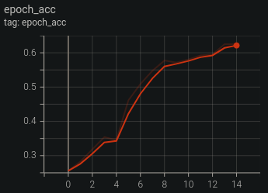
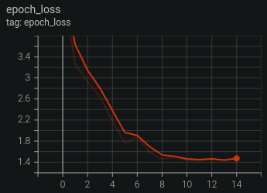
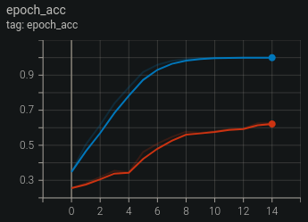
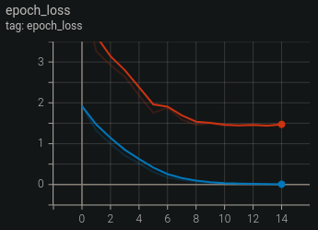
#Design the model
def design_model(input_shape):

model = tf.keras.models.Sequential([

tf.keras.layers.Conv2D(64, (3,3), activation='relu', input_shape=input_shape),
tf.keras.layers.MaxPooling2D((3,3), strides=(2,2), padding='same'),
tf.keras.layers.BatchNormalization(),

tf.keras.layers.Conv2D(64, (3,3), activation='relu'),
tf.keras.layers.MaxPooling2D((3,3), strides=(2,2), padding='same'),
tf.keras.layers.BatchNormalization(),

tf.keras.layers.Conv2D(64, (2,2), activation='relu'),
tf.keras.layers.MaxPooling2D((3,3), strides=(2,2), padding='same'),
tf.keras.layers.BatchNormalization(),
tf.keras.layers.Dropout(0.3),

tf.keras.layers.Flatten(),
tf.keras.layers.Dense(64, activation='relu'),
tf.keras.layers.Dense(len(np.unique(targets)), activation='softmax')
])

return model

#Model Creation
input_shape = (Xtrain.shape[1], Xtrain.shape[2], 1)
model = design_model(input_shape)

model.compile(optimizer = tf.keras.optimizers.Adam(learning_rate=0.001),
loss = 'sparse_categorical_crossentropy',
metrics = ['acc'])

#COMPILATION
history = model.fit(Xtrain, ytrain,
validation_data = (Xval, yval),
epochs = 15,
batch_size = 64,
callbacks=[tensorboard_callback])

Adam Random Split

#Design the model
def design_model(input_shape):

model = tf.keras.models.Sequential([

tf.keras.layers.Conv2D(64, (3,3), activation='relu', input_shape=input_shape),
tf.keras.layers.MaxPooling2D((3,3), strides=(2,2), padding='same'),
tf.keras.layers.BatchNormalization(),

tf.keras.layers.Conv2D(64, (3,3), activation='relu'),
tf.keras.layers.MaxPooling2D((3,3), strides=(2,2), padding='same'),
tf.keras.layers.BatchNormalization(),

tf.keras.layers.Conv2D(64, (2,2), activation='relu'),
tf.keras.layers.MaxPooling2D((3,3), strides=(2,2), padding='same'),
tf.keras.layers.BatchNormalization(),
tf.keras.layers.Dropout(0.3),

tf.keras.layers.Flatten(),
tf.keras.layers.Dense(64, activation='relu'),
tf.keras.layers.Dense(len(np.unique(targets)), activation='softmax')
])

return model

#Model Creation
input_shape = (Xtrain.shape[1], Xtrain.shape[2], 1)
model = design_model(input_shape)

model.compile(optimizer = tf.keras.optimizers.Adam(learning_rate=0.001),
loss = 'sparse_categorical_crossentropy',
metrics = ['acc'])

MFCC_Adam_64_Model: ADAM 64 RERUN
07:08 Target: 09:08

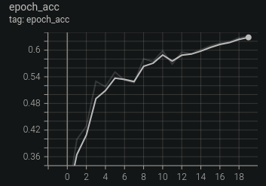
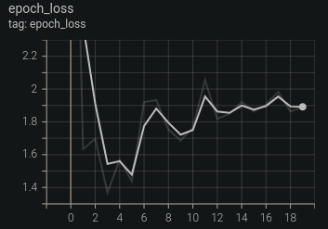
DETAILS:
- Epochs: 20
- Accuracy: 0.63
- Loss:1.89
MFCC_Batch64_Added_Layer_Model: ADAM 64 BATCH 64 ADDED LAYER
07:38 Target: 09:38

DETAILS:
- Epochs 30
- Accuracy: 0.62
- Loss: 1.762
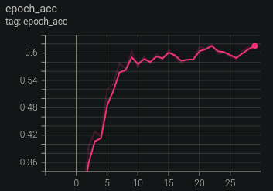
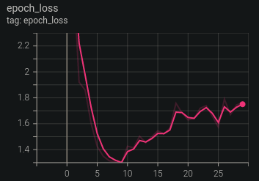
Adam_Ohra
09:57

DETAILS:
- Epochs: 15
- Accuracy: 0.59
- Loss: 1.67

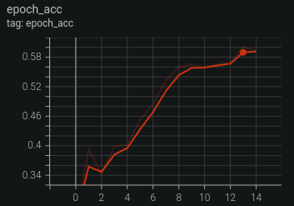
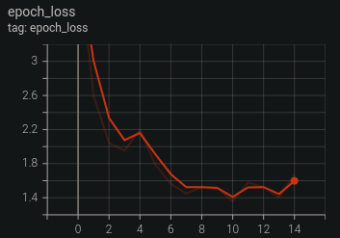
Adam_random_split
10:28

Adam Ohra
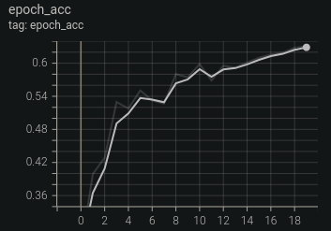
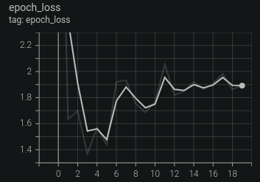
Accuracy: 0.62
Loss: 1.89

Imbarazz

Adam Random Split

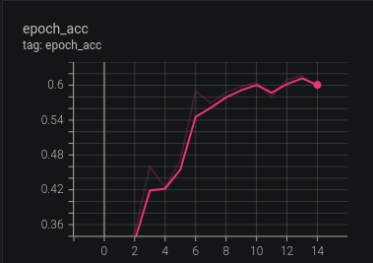
Acc: 0.59
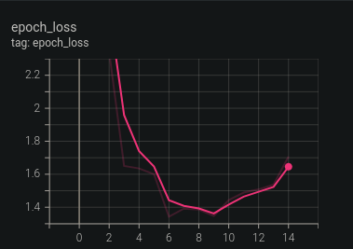
loss: 1.7

